Building a Solid Foundation for
Concrete Floor Coatings
A Guide to Inspection and Surface Preparation
BY STEVEN REINSTADTLER, COVESTRO LLC
Years ago, when my wife CJ and I were having our house built, we visited the construction site often to see the different stages in the process. Early in the build, I recall her commenting on how long the foundation work was taking and how much detail went into the setup and completion. She wanted the builder to quickly get to the exciting parts of the project — the walls, the roof and the interior of the house.
“Well, you need to have a good foundation to support the rest of the house,” I joked, “we don’t want it to fall down after a few years.”
A successful concrete floor coating application is much like building a house. The site must first be inspected and laid out, and the groundwork and foundation prepared. Only then should the floor coating system of choice be applied. And just like building a house, shortchanging the foundation puts the entire project at risk.

Achieving a durable, aesthetically pleasing concrete floor requires care in preparing the surface and applying the coating system. Photo: istock.com / piovesempre

Methodically creating a great foundation through proper inspection and surface preparation is crucial to create a long-lasting floor coating project. For every concrete floor surface, several steps in the surface preparation process should be considered:
- Survey and inspect;
- Repair;
- Clean; and
- Profile.
While it would be impossible to cover every detail and nuance of surface preparation here, this article will focus on the primary points and methods.

SURVEY AND INSPECT
This first step is very important, since it determines which methods of surface preparation will be employed. During the inspection, the contractor should survey the space to be coated, looking for cracks, spalling, damaged joints, laitance and chemical attack of the concrete substrate. In addition, the contractor should note any stains, contaminants or existing coatings.
A preliminary concrete moisture evaluation can also be performed, but the evaluations can change significantly if the floor has existing sealers or coatings or requires repairs and profiling. Moisture evaluation testing is best performed after any repairs and remediation are complete. For future reference, the floor coating subcommittee C.8.3 of the Society for Protective Coatings (SSPC) is working on a guide that focuses on multiple methods to test for moisture content.
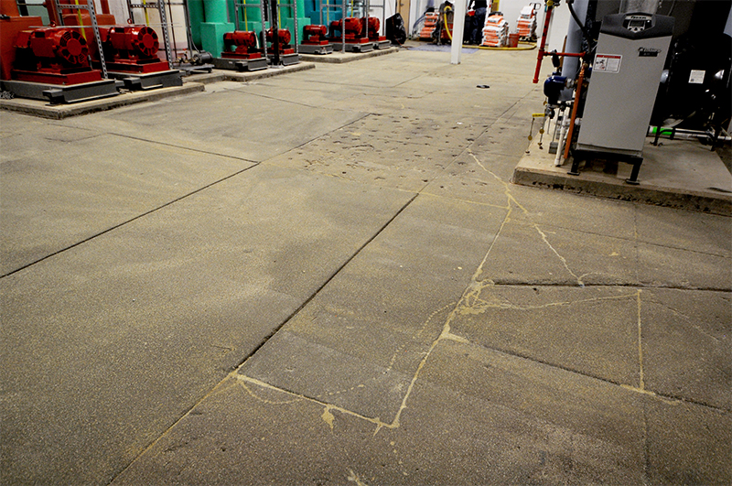During an initial inspection of a typical concrete floor like this one, the contractor may discover multiple issues to address, such as spalling, cracks, an uneven profile and old joint filling compound. All photos courtesy of the author Unless INDICATED OTHERWISE
Once the observations are completed, the contractor can use several industry references to determine the best course of action for the specific substrate. The following are two excellent sources of information.

ICRI Guideline Number 310.2R
This guideline discusses surface preparation method selection, definition of common terms, the mechanics behind each method, concrete surface profiles and a method selector process. It also contains a thorough method summary and several helpful summary charts.

NACE No. 6 / SSPC – SP 13 Joint Standard
This standard covers the definition of industry terms, inspection procedures before surface preparation, surface preparation, inspection and classification of prepared concrete surfaces, acceptance criteria and safety and environmental requirements. The appendix covers suggested acceptance criteria and surface preparation methods.
As with any floor coatings project, the coating system manufacturer should be a prime resource for recommendations on repair and preparation of the substrate specific to their coating and possible surface issues.
During and after the floor assessment process, consider and manage the facility owner’s expectations for longevity, cost and appearance.

SURFACE PREPARATION
The results of the inspection and survey will dictate the inclusion, method and magnitude of one or more of the following surface preparation actions: repair, cleaning and profiling.

Repairing
For repairs, let’s assume that the concrete slab does not require total replacement. If the concrete floor has significant spalling, flaking, cracks or other structural issues, it will need repairs prior to further preparation. This step helps ensure that the surface will be sound and homogenous for the subsequent steps of cleaning, profiling and coating application.
Smaller cracks in the concrete substrate should be filled with a cementitious or polymer-based crack repair material and allowed to cure per the manufacturer’s recommendations.
Small damaged areas may be cut out and repaired with cementitious or polymer-modified mortars and concrete. For larger areas with more superficial damage, a cementitious or polymer-modified overlay may be applied. Make sure to follow the cure time for coating along with recommendations from the mortar or overlay and coating manufacturers, as premature coating application can result in disbondment and defects due to alkalinity and moisture issues.
The repair process should also address cracks and joints. Small cracks may be filled with a cement- or polymer-based material. Larger cracks, however, may need to be chased or enlarged, in order to be filled with a suitable crack repair material.

Cleaning
Let’s assume the concrete surface to be coated is sound and free of undesired cracks, and it has the desired profile. The surface may still require cleaning to address more topical issues, such as stains, mold, organic contaminants, or residual concrete-curing compounds. Common methods of surface cleaning include:
- Air blast;
- Steam cleaning;
- Scrubbing with detergents or solvent by manual or pressure washing; and
- Low-pressure water jetting.
The appropriate cleaning method depends on the nature of the contaminant. For example, a detergent solution or steam cleaning might be used for removing oil, grease or glycol contamination. For removing loose materials, dirt and dust, a contractor may employ pressure washing, vacuum cleaning or air blast cleaning. After cleaning with liquids, the surface may be wet-vacuumed to remove any remaining water. Allow the surface to dry completely after any cleaning procedure that involves liquids. This drying process can be facilitated with heaters and fans.
For applying a thin, clear protective coating to an existing decorative floor finish, an electric floor machine or auto scrubber may be used to remove residual dirt and open up the surface slightly using a black floor pad.
The necessity of thorough cleaning and drying cannot be stressed enough: Cleaning solutions or solvents that have not been removed or allowed to evaporate from the concrete surface can greatly affect the floor coating’s adhesion and long-term durability.

Profiling
Depending on the coating system and final system thickness, there are industry-wide recommendations for the corresponding surface profile necessary for good adhesion. This article focuses on sealers, thin- and high-build coatings applied up to a thickness of 40 mils. The International Concrete Repair Institute (ICRI) has established guidelines for measuring the concrete surface profile, or CSP. The scale ranges from a fairly smooth finish at CSP 1 up to a very coarse finish at CSP 10. Sealers and thin-film floor coatings typically require a profile in the CSP 1-3 range, while thicker high-build floor coatings need a profile in the 3-5 range.
Many methods exist for creating the desired concrete surface profile on new or existing concrete, and each method has its benefits and drawbacks to consider. The method should be chosen after considering several factors, such as the initial floor inspection, desired CSP, owner’s aesthetic expectations, project timing, coating manufacturer recommendations and the age of the substrate, to name just a few.
To create a surface profile in the range of CSP 1-2, grinding or acid etching may be used. Grinding offers the advantage of being a dry process, which shortens the preparation time. A relatively easy process, grinding also doesn’t cause “bruising” — an undesirable effect associated with micro-fracturing of the surface. Drawbacks include removing residual dust and undesired patterning effects.
Acid etching involves applying an acid solution to the concrete, which attacks alkali constituents of the concrete such as carbonates, calcium hydroxide and limestone. The process produces a uniform surface, avoids bruising and is fairly easy to perform with portable equipment. Drawbacks include the need to correctly carry out the added neutralization step and the health and safety considerations of working with the acid solution. And since acid etching is a wet process, it requires wet vacuuming followed by a drying period.
For surface profiles in the CSP 2-5 range, a variety of common mechanical abrasion methods are available. These include, in order of aggressiveness: needle scaling; dry and wet abrasive blasting; shot blasting; and scarifying.
Dry abrasive blasting is a standard form of mechanical abrasion that involves directing a stream of blast media (such as aluminum oxide, silicon carbide or garnet) in a high-pressure air stream at the substrate to erode the surface. When done by a skilled contractor, the process typically yields a uniform surface profile. The contractor can adjust technique and media size to impart a light brush blast profile to one of a moderate profile. This method offers the advantages of a lack of surface micro-fracturing and requires no drying because no liquids are involved. Dry abrasive blasting can also remove old coatings from the concrete as long as they are not soft and resilient. The main drawback is that the process generates considerable dust and a dry waste stream. New equipment has focused on mitigating environmental dust contamination and containment/reuse of the blasting media.
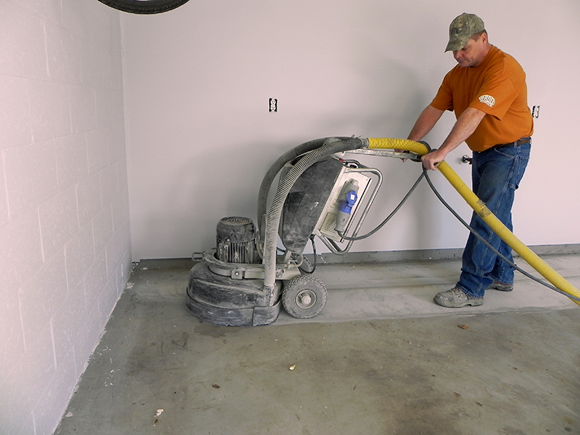When a concrete floor is in generally good condition, a portable floor grinding machine may be used to prepare the surface with a suitable profile.
Shot blasting is another popular method, used to impart a coarser profile or on particularly high compressive strength concrete. This method uses larger media, such as steel shot, accelerated to high speeds and impacted on to the surface to pulverize the concrete. The advantages of shot blasting include rapid material removal, a dry process and recyclability of the media. The machinery vacuums up the steel shot media and is effective at containing the dust generated in the process. Drawbacks include the possibility of inconsistent patterning, resulting in a striping effect, and its limited ability to remove soft or resilient compounds, such as elastomeric coatings and adhesives. Also, some bruising of the surface can occur, depending on the size of the steel shot, which could necessitate an additional, less-aggressive abrasion step to get to sound concrete.
Additional methods for achieving a CSP of 3 or higher include high and ultra-high pressure water-jetting. In these more aggressive wet profiling methods, water pressures of 5,000 psi to upwards of 40,000 psi rapidly remove old coatings and adhesives as well as profile the top layer of the concrete. Possible drawbacks to consider with these methods include the water and mist produced in the work environment, addressing the waste stream and the time needed to dry the concrete before the coating application.

CONCLUSION
Once the time and effort have been put into inspecting the concrete floor space, determining the technical and owner’s needs, and executing the proper surface preparation, the floor is ready to accept a sealer or coating designed to meet or exceed the manufacturer’s expected service life. As author and cleric Gordon B. Hinckley said, “You can’t build a great building on a weak foundation.” Likewise, you can’t build a high-performance floor coating system on a concrete floor without diligent and focused attention to surface preparation. D+D

ABOUT THE AUTHOR: Steven Reinstadtler is the construction market manager for the coatings, adhesives, and sealants (CAS) business unit of Covestro LLC in Pittsburgh, PA. He works closely with contractors, companies and organizations that build infrastructure with durability and sustainability in mind by educating the market on high-performance coatings and sealant options. Reinstadtler has been with Covestro (formerly Bayer MaterialScience) for over 28 years in technical and marketing management positions. He holds a degree in chemistry with a polymer science option from the University of Pittsburgh and is an active member of professional societies such as AIA, CSI, ACS, SSPC, CPI, ACA, ESWP and PDA.

